

American International University-Bangladesh (AIUB)  
**Department of Computer Science  
Faculty of Science & Technology (FST)**

**Smart Farmers**

A Software Requirement Engineering Project Submitted

By

|  |  |  |  |  |
| --- | --- | --- | --- | --- |
| **Semester: Fall_24_25** | | **Section:** | **Group Number:** | |
| SN | Student Name | Student ID | Contribution in % (CO+CO2) | Individual Marks |
| 7 | Prithanjoly Biswas Pew | 20-43126-1 | 100 |  |
| 17 | Ahnaf Abdullah Zayad | 21-45019-2 | 100 |  |
| 20 | Sadman Shopan | 21-45205-2 | 100 |  |
|  |  |  |  |  |

The project will be Evaluated for the following Course Outcomes

|  |  |  |
| --- | --- | --- |
| **EVALUATION CRITERIA** | Total Marks (50) | |
|  | |
| Introduction [Section 1.1-1.4], Format, Submission, Defense | [10 Marks] |  |
| System Overall Description & Functional Requirements | [10 Marks] |  |
| System Quality Attributes and Project Requirements | [10 Marks] |  |
| UML and E-R Diagram with Data Dictionary | [10 Marks] |  |
| UI/UX Prototyping | [10 Marks] |  |

Software Requirements Specification

for

<Smart Farmers>

Version 2.0 approved

Prepared by

<Prithanjoly Biswas Pew>

<Ahnaf Abdullah Zayad>

< Sadman Shopan>

<American International University-Bangladesh>

<14/01/2025>

Table of Contents

Revision History 3

1. Introduction 4

1.1 Purpose 4

1.2 Document Conventions 4

1.3 Intended Audience and Reading Suggestions 4

1.4 References 4

2. Overall Description 4

2.1 Product Perspective 4

2.2 Product Functions 5

2.3 User Classes and Characteristics 5

2.4 Hardware and Operating Environment 5

2.5 Design and Implementation Constraints 5

2.6 User Documentation 5

3. System Requirements 6

3.1 System Features 6

3.1.1 Software Login 6

3.2 Non-Functional/Quality Requirements 6

3.3 Project Requirements 6

4. Design and Interface Requirements 7

4.1 UML Diagrams 7

4.2 Data Dictionary 7

4.3 UI/UX Design Specification 7

# Revision History

|  |  |  |  |
| --- | --- | --- | --- |
| **Name** | **Date** | **Reason for Changes** | **Version** |
| Smart Farmers | 25/12/24 | Initial Draft web application | 1.0 |
| Smart Farmers | 12/01/25 | Upgrade to mobile application | 2.0 |

# Introduction

## Purpose

The document defines the software requirements for the "Smart Farmers" mobile app. It explains the app’s features, functionality, and goals to ensure effective communication among developers, analysts, and users. The second version (2.0) focuses on core features like crop health analysis, personalized farming advice, and 7-day weather forecasts. The document highlights the app’s purpose and alignment with business goals, aiming to solve key challenges faced by small-scale and amateur farmers. It provides a clear and complete overview of the system’s functionalities, ensuring all necessary components are addressed for a successful and practical implementation.

**1.1.1 Scope of the Product**

The **"Smart Farmers"** application is an AI-powered mobile platform with the key functionalities:

* **Crop Health Analysis:** Analysis of crop images using AI to identify diseases, pests and nutrient deficiencies.
* **Personalized Recommendations:** Advice on crop management and pesticide control based on user entered data.
* **Weather Forecasting:** Accurate 7-day weather forecasts to support effective planning of agricultural activities.

**1.1.2**    **Purpose of the Software**

The "Smart Farmers" app is designed to help small-scale and beginner farmers by using artificial intelligence and mobile technology to solve key farming challenges. The application aims to:

1. **Enhance Agricultural Productivity**: It provides helpful advice to improve crop management.
2. **Reducing Crop Losses**: It helps farmers detect and address crop health problems early, preventing financial losses and yield reduction.
3. **Supporting Climate Adaptation**: It gives accurate weather forecasts to help farmers deal with climate challenges.

**1.1.3**    **Business Requirements**

The business requirements for the **"Smart Farmers"** application include:

* **Accessibility and Usability:** Create a simple interface that works for people with different levels of tech skills.
* **Scalability and Reliability:** Make sure the app can handle more users as it grows and always provides accurate information.
* **Affordability:** Keep the costs low so small-scale farmers can easily access advanced farming tools.
* **Integration with External Resources:** Allow smooth connection with weather updates, external databases, and agricultural research platforms.

## Document Conventions

The following standards have been added in this Software Requirements Specification (SRS) document to ensure clarity, consistency, and ease of understanding:

**1.2.1**    **Formatting Conventions**

* **Headings and Subheadings:**
  + Major sections are formatted in bold and numbered.
  + Subsections are formatted in bold and numbered.
* **Text Formatting:**
  + **Bold Text:** Used to highlight important terms, system names, or concepts.

**1.2.2**    **Requirements Identification**

* Priorities are explicitly stated for each requirement using the following categories:
  + **High Priority (HP):** Critical features necessary for the core functionality of the application.
  + **Medium Priority (MP):** Important features that enhance user experience or provide additional value.
  + **Low Priority (LP):** Optional features that can be implemented in future releases.

**1.2.3**    **Standards and Terminology**

* **Shall, Should, and May:**
  + **Shall:** Indicates a mandatory requirement.
  + **Should:** Indicates a recommended but not mandatory requirement.
  + **May:** Indicates an optional feature or functionality.
* **Acronyms and Abbreviations:** All acronyms are defined in the document where they first appear and included in the glossary (e.g., AI for Artificial Intelligence).

## Intended Audience and Reading Suggestions

This Software Requirements Specification (SRS) document is intended for a diverse group of stakeholders involved in the development, implementation, and use of the **"Smart Farmers"** application. Each group may focus on specific sections of the document relevant to their roles and responsibilities.

**1.3.1**    **Intended Audience**

* **Developers:** Focus on Functional Requirements, System Features, and Interface Requirements.
* **Project Managers:** Focus on Purpose, Scope, Business Requirements, and Priorities.
* **Testers:** Focus on Functional Requirements, Use Cases, and Performance Requirements.
* **Marketing Staff:** Focus on Purpose, Scope, Business Requirements, and Product Benefits.
* **End Users (Farmers):** Focus on Overview and Use Case Scenarios.
* **Documentation Writers:** Focus on the entire document, especially Functional and Interface Requirements.

**1.3.2**    **Reading Suggestions**

* **All Readers:** Start with the Introduction to grasp the purpose, scope, and context.
* **Developers and Testers:** Focus on Functional Requirements and System Features for technical details.
* **Project Managers:** Review Business Requirements and Scope to align objectives with goals.
* **Marketing Staff:** Highlight Purpose and Business Objectives for key benefits and audience value.
* **End Users:** Check Overview and Use Case Scenarios for usability and benefits.
* **Documentation Writers:** Study the entire document for insights to create user materials.

## References

* Babashli, Bakhtiyar. (2022). Smart Farming Applications on Agriculture. 2.
* https://www.sciencedirect.com/science/article/pii/S1877050919317168

# Overall Description

## Product Perspective

**2.1.1**    **Problem Background**

The "Smart Farmers" app was created to help amateur farmers overcome common challenges in farming. Many farmers lack access to accurate information on crop care, pest control, soil health, and weather updates, leading to lower productivity and financial losses. Unpredictable weather due to climate change makes farming even harder. Existing tools are often complicated and not designed for their needs, highlighting the need for a simple, all-in-one solution.

**2.1.2**    **Context and Origin**

The **"Smart Farmers"** application is a new, self-contained product. It is not a follow-on member of a product family but rather a ground-up development aimed at integrating modern AI technologies with agricultural practices.

**2.1.3**    **Business Objectives**

The development of the **"Smart Farmers"** application aligns with the following business objectives:

1. **Enhance Agricultural Productivity:** Provide actionable insights and recommendations that help farmers maximize crop yields and efficiency.
2. **Reduce Crop Losses:** Detect and address crop health issues early through AI-driven diagnostics, minimizing financial losses.
3. **Promote Sustainable Agriculture:** Encourage practices that improve soil health and reduce environmental impact.
4. **Foster Economic Growth:** Improve the livelihoods of farming communities by enabling them to adopt cost-effective and efficient farming practices.

## Product Functions

The **"Smart Farmers"** application provides a comprehensive set of functions designed to address the challenges faced by small-scale and amateur farmers. These functions are summarized below:

**2.2.1**    **Major Functions**

1. **Crop Health Analysis:**
   * Allow users to upload crop images for AI-driven analysis.
   * Detect diseases, pests, and nutritional imbalance in crops.
   * Provide real-time diagnostic results and actionable recommendations.
2. **Personalized Recommendations:**
   * Offer tailored advice on crop management practices based on location, crop type, and specific issues identified.
   * Suggest solutions for pest control, irrigation schedules, and soil improvement.
3. **Weather Forecasting:**
   * Deliver accurate 7-day weather forecasts.
   * Provide alerts for extreme weather events to help farmers plan agricultural activities.
4. **User Profile and Data Management:**
   * Allow users to create and manage profiles, including farm details and crop preferences.
   * Enable storage and retrieval of historical data for tracking progress and making informed decisions.
5. **Integration with External Systems:**

Interface with weather services, agricultural databases, and IoT-based farming tools.

## User Classes and Characteristics

**2.3.1**    **User Classes**

1. **Small-Scale Farmers (Primary Users):**
   * **Frequency of Use:** Frequent users; likely to use the application daily or weekly for monitoring and planning.
   * **Functions Used:** Crop health analysis, personalized recommendations, weather forecasting, and knowledge base.
   * **Technical Expertise:** Low to moderate; may have limited familiarity with technology.
   * **Educational Level:** Varies; likely includes individuals with basic education or agricultural experience.
2. **Agricultural Consultants:**
   * **Frequency of Use:** Moderate; used during consultations or research for farmers.
   * **Functions Used:** Advanced diagnostics, knowledge repository, and user profile data analysis.
   * **Technical Expertise:** Moderate to high; typically familiar with agricultural technology and practices.
   * **Educational Level:** Advanced; likely includes agronomists, agricultural scientists, or extension officers.
3. **Government and Non-Governmental Organizations (NGOs):**
   * **Frequency of Use:** Moderate; used for monitoring agricultural trends, supporting policymaking, or providing aid.
   * **Functions Used:** Aggregated data analysis, regional weather trends, and knowledge base access.
   * **Technical Expertise:** Moderate; familiar with using digital tools for data collection and analysis.
   * **Educational Level:** Advanced; includes policymakers, agricultural program managers, and researchers.
4. **Agricultural Enthusiasts and Hobbyists:**
   * **Frequency of Use:** Occasional; used for personal or experimental farming activities.
   * **Functions Used:** Crop health analysis, knowledge base, and basic weather forecasting.
   * **Technical Expertise:** Low to moderate; likely tech-savvy but with limited farming experience.
   * **Educational Level:** Varies; includes individuals with an interest in agriculture or gardening

**2.3.2**    **Priority User Classes**

1. **Small-Scale Farmers:** As the primary users, their needs and ease of use are the top priorities. The application must cater to their challenges with simple navigation, clear outputs, and localized content.
2. **Agricultural Consultants:** These users provide expert advice to farmers. Their satisfaction ensures credibility and broader adoption of the application.

**2.3.3**    **Less Critical User Classes**

1. **Government and NGOs:** While important for large-scale planning and implementation, their usage is less frequent compared to the primary users. Features for this group can be secondary in the initial releases.
2. **Agricultural Enthusiasts and Hobbyists:** These users represent a secondary market and are less critical to the success of the core objectives of the application.

## Hardware and Operating Environment

The **"Smart Farmers"** application is designed to operate on a range of hardware platforms and within specific software environments to ensure compatibility, accessibility, and usability for its intended audience.

**2.4.1**    **Hardware Platform**

1. **Mobile Devices:**
   * **Smartphones:** Minimum hardware specifications:
     + Processor: Quad-core or higher.
     + RAM: 2 GB or more.
     + Storage: At least 100 MB of free space for installation and updates.
     + Camera: Minimum 8 MP for capturing crop images.
   * **Tablets:** Must meet or exceed the smartphone specifications for performance consistency.
2. **Optional Integration with IoT Devices:**
   * Supports compatibility with IoT-based farming tools, such as soil sensors and weather stations, via Bluetooth or Wi-Fi.

**2.4.2**    **Operating System Requirements**

1. **Mobile Operating Systems:**
   * **Android:**
     + Minimum version: Android 8.0 (Oreo) or higher.
   * **iOS:**
     + Minimum version: iOS 12.0 or higher.
2. **Web Interface (Future Scope):**
   * A browser-based version is planned for development in subsequent phases, supporting modern browsers such as Chrome, Firefox, and Edge.

**2.4.3**    **Software Components**

1. **AI and Machine Learning Models:**
   * Deployed on a cloud platform for real-time crop image analysis and recommendations.
   * Requires a stable internet connection for cloud-based processing.
2. **Weather Forecasting API:**
   * Integration with a third-party weather service API for real-time and accurate weather updates.
3. **Database Management System:**
   * Cloud-based databases for storing user profiles, historical data, and crop health analytics.
4. **Localization Support:**
   * Support for multiple languages and region-specific data formats.

**2.4.4**    **Operating Environment**

1. **Network Requirements:**
   * Internet Connectivity: Required for accessing weather forecasts, cloud AI services, and updates.
   * Offline Mode: Basic functionality, such as accessing previously saved recommendations and weather data, is available offline.
2. **Physical Environment:**
   * Designed to be used in rural and agricultural settings, often with limited or intermittent network connectivity.
   * Optimized for operation in low-light and outdoor conditions for ease of use in the field.
3. **Performance Considerations:**
   * The application is lightweight and optimized to function smoothly on devices with limited processing power and memory.
   * Battery-efficient design to minimize power consumption during extended usage.

## Design and Implementation Constraints

The development of the **"Smart Farmers"** application must adhere to several design and implementation constraints to ensure compliance with technical, regulatory, and operational requirements.

**2.5.1**    **Corporate and Regulatory Policies**

* **Data Privacy Regulations:** The application must comply with data protection laws such as GDPR (General Data Protection Regulation) and similar regional regulations to ensure user data privacy and security.
* **Environmental Standards:** The application should encourage sustainable agricultural practices in line with global environmental and agricultural policies.

**2.5.2**    **Hardware Limitations**

* **Device Performance:** The application must be optimized to run on low-spec devices commonly used in rural areas, with constraints on memory (minimum 2 GB RAM) and processing power.
* **Camera Quality:** AI-driven crop health analysis requires adequate image quality. The minimum hardware constraint is an 8 MP camera for effective diagnostics.

**2.5.3**    **Interfaces to Other Applications**

* **Weather API Integration:** The application relies on third-party weather services for real-time forecasting, necessitating robust API integration and adherence to their usage limits and data formats.
* **IoT Device Support:** The system must be compatible with standard communication protocols like Bluetooth and Wi-Fi to integrate with IoT-enabled farming tools.

**2.5.4**    **Language Requirements**

* **Localization:** The application must support multiple languages to cater to diverse regional user bases. All text, labels, and recommendations must be translatable.

**2.5.5**    **Security Considerations**

* **User Authentication:** Secure login mechanisms (e.g., email, phone number with OTP) must be implemented to protect user accounts.
* **Data Encryption:** All user data, including images and personal information, must be encrypted during storage and transmission.
* **Role-Based Access Control:** Specific features (e.g., advanced analytics) must be accessible only to authorized users.

## User Documentation

1. **User Manual:**
   * A detailed step-by-step guide covering all application features and functionalities.
   * Sections include:
     + Installation and setup instructions.
     + Overview of the user interface.
     + How-to guides for core features such as crop health analysis, weather forecasting, and personalized recommendations.
     + Troubleshooting common issues.
2. **Online Help:**
   * Context-sensitive help integrated within the application.
   * Users can access relevant guidance and tips directly while using specific features.
3. **Tutorials:**
   * Interactive tutorials and videos demonstrating:
     + Uploading crop images for analysis.
     + Interpreting crop health reports and recommendations.
     + Accessing and understanding weather forecasts.
   * Tutorials will be accessible within the application and on the official website.

# System Requirements

## System Features

### Software Login

**Functional Requirements (FRs)**

 1.1 The software shall allow users to log in with their given username and password.  
 1.2 The login credentials (username and password) will be verified with database records.  
 1.3 If the login is successful, the home page of the user account will be displayed.  
 1.4 If the username and/or password is incorrect, a error message will be generated.  
 1.5 If the number of login attempts exceeds the limit (3 times), the system shall block the user account login for one hour. (*Optional function*)

**Priority Level:** High

**Precondition:** The user must have a valid user ID and password.

**Cross-References:** (Security Management), (Data Management).

**3.1.2**    **Crop Health Analysis**

**Description:** The feature enables users to upload crop images for AI-driven analysis, diagnosing diseases, pesticides, and nutritional deficiencies.

**Functional Requirements (FRs):**

 2.1 The system shall allow users to upload images of crops.  
 2.2 The software shall analyze uploaded images using AI models to detect crop health issues.  
 2.3 Diagnostic results, including identified diseases, pesticides or deficiencies shall be displayed to the user.  
 2.4 Recommendations for mitigating the identified issues shall be provided.

**Priority Level:** High

**Precondition:** The user must have a valid account and upload clear crop images.

**Cross-References:** 1.3(Weather Forecasting).

**3.1.3**    **Weather Forecasting**

**Description:** Provides users with accurate 7-day weather forecasts and extreme weather alerts to aid in planning agricultural activities.

**Functional Requirements (FRs):**

 3.1 The system shall display daily weather forecasts for the next seven days.  
 3.2 The application shall alert users of extreme weather events (e.g: drought, storms, heavy rainfall).  
 3.3 Users shall be able to select their geographic location for localized weather updates.

**Priority Level:** Medium

**Precondition:** A stable internet connection and location in google map is required for real-time updates.

**Cross-References:** 1.2(Crop Health Analysis)

## Non-Functional/Quality Requirements

**QA1: Usability:** A trained user shall be able to upload a crop image, receive a diagnostic report and access recommendations.

**Priority Level:** Medium **Precondition:** N/A  
**Cross-references:** QA2 (Performance), QA4 (User Interface).

**QA2: Performance:** The application shall handle up to 1,000 concurrent users without significant degradation in performance, maintaining response times of less than 5 seconds for 95% of user actions.

* **Priority Level:** High
* **Precondition:** System must be deployed on a scalable cloud platform.
* **Cross-references:** QA1 (Usability), QA5 (Scalability).

**QA3: Security:** All user data, including images and personal information, shall be encrypted during transmission and storage using industry-standard encryption algorithms.

* **Priority Level:** High
* **Precondition:** Encryption libraries must be integrated.
* **Cross-references:** QA5 (Scalability), QA6 (Data Privacy).

**QA4: Scalability:** The system shall be capable of scaling horizontally to support up to 10000 active users without requiring downtime for maintenance or upgrades.

* **Priority Level:** High
* **Precondition:** Cloud infrastructure must support dynamic scaling.
* **Cross-references:** QA2 (Performance), QA3 (Security).

**QA6: Data Privacy:** The application shall comply with data protection regulations such as GDPR, ensuring user consent is obtained before collecting or processing personal data.

* **Priority Level:** High
* **Precondition:** Privacy policy must be implemented.
* **Cross-references:** QA3 (Security).

**QA7: Accessibility:** The application shall comply with WCAG 2.1 standards to ensure accessibility for users with disabilities, including text-to-speech support and adjustable font sizes.

* **Priority Level:** Medium
* **Precondition:** Accessibility guidelines must be integrated into the design and development phases.
* **Cross-references:** QA4 (Localization), QA1 (Usability).

## Project Requirements

**3.3.1**    **Time, Budget, and Human Resources**

Effort estimation is based on the **COCOMO II** model, which provides an approximate measure of project size, effort, and duration.

* **Project Size:** Medium (based on the number of features and complexity of AI integration).
* **Effort Estimation:**
  + **Estimated Effort (Person-Months):** 25 PM (calculated for an intermediate project).
  + **Development Duration:** 6 months (approx. 26 weeks).
* **Human Resources:**
  + **Development Team:**
    - 2 Frontend Developers.
    - 2 Backend Developers.
    - 1 AI/ML Specialist.
    - 1 Database Administrator.
  + **Testing Team:**
    - 2 QA Testers.
    - 1 Automation Engineer.
  + **Management:**
    - 1 Project Manager.
    - 1 Business Analyst.
  + **Other Roles:**
    - 1 UI/UX Designer.
    - 1 Technical Writer.
* **Budget Estimation:**
  + **Total Cost:** $120,000 USD.
  + **Breakdown:**
    - Personnel Costs: $100,000 USD.
    - Tools and Licenses: $10,000 USD.
    - Cloud Services: $5,000 USD.
    - Miscellaneous Costs: $5,000 USD.

**3.3.2**    **Tools**

The development and testing of the **"Smart Farmers"** application will require the following tools and software:

* **Development Tools:**
  + Flutter or React Native (cross-platform development).
  + Backend Framework: Node.js or Django.
  + Database: Firebase
* **Testing Tools:**
  + Selenium (for automation testing).
  + Postman (for API testing).
* **Other Tools:**
  + Figma (for UI/UX design).
  + GitHub/GitLab (for version control).
  + Cloud Services: AWS or Google Cloud for hosting and AI/ML processing.

**3.3.3**    **Services and Additional Costs**

* **Third-Party API Integration:**
  + Weather Forecasting API: 120000 TK/year.
  + Payment for AI model hosting on a cloud platform: 200000 TK/year.
* **Training and Support:**
  + Training sessions for farmers and consultants on how to use the application: 300000 TK.
* **Miscellaneous Costs:**
  + Marketing and promotion: 400000 TK.
  + User documentation printing (optional):100000 TK.

# Design and Interface Requirements

## UML Diagrams

**Use Case Diagram**

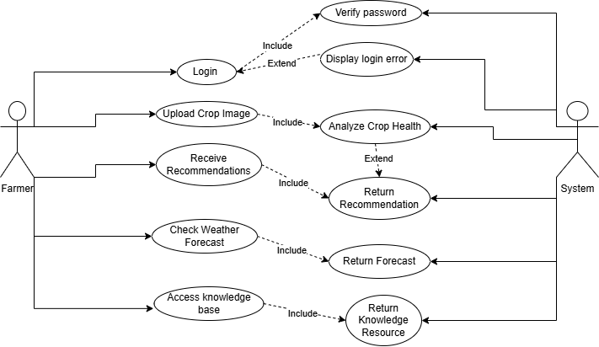

**Class Diagram**

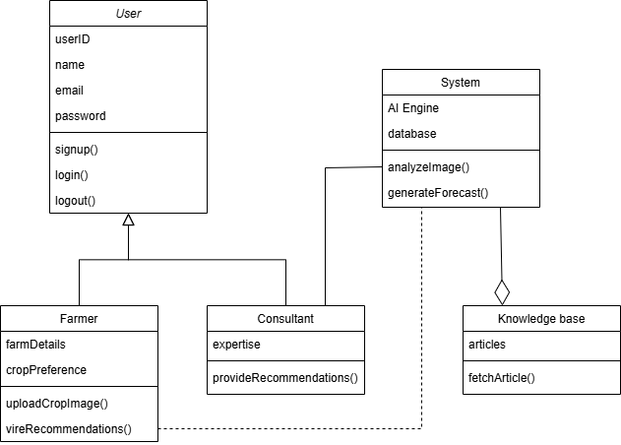

**Activity Diagram**

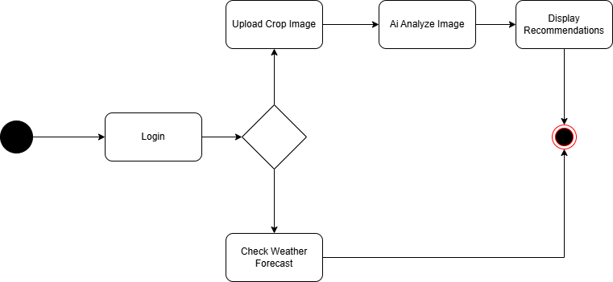

**ER Diagram**

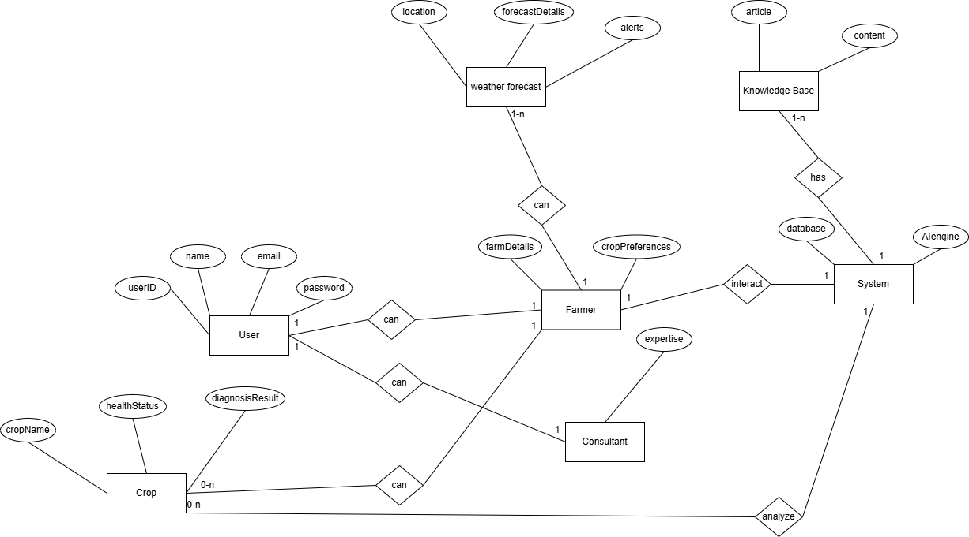

## Data Dictionary

|  |  |  |  |  |
| --- | --- | --- | --- | --- |
| Entity | Attribute | Type/Size | Validation | Key |
| User | userID | Number(5) | 1-99999 | Primary |
| User | Name | Text(10) | Required |  |
| User | Email | Email | Required |  |
| User | Password | password | 8 Characters |  |
| Crop | cropID | Number(5) | Required | Primary |
| Crop | Name | Text(10) | Not Null |  |
| Crop | healthStatus | Text(10) |  |  |
| Crop | diagnosisResult | Text(10) |  |  |
| WeatherForecase | forecastID | Number(5) | Required | Primary |
| WeatherForecase | Location | Text(10) |  |  |
| WeatherForecase | forecastDetails | Text(10) |  |  |
| WeatherForecase | alert | Text(10) |  |  |

## UI/UX Design Specification

For designing a prototype of the proposed solution, consider using tools such as:

1. **Figma**: A collaborative interface design tool ideal for creating wireframes and high-fidelity prototypes.

**Prototype**:

